 Shalbourne Parish Council
Council Members Details 2008-2009



Lesley Green
Chairman
Planning, Press,
Little Court Rivar Road
Tel 01672 870488
lesleyegreen@hotmail.co.uk


Geoff Tyler
Vice Chairman,
Planning & Flooding
Marymere House, Salisbury Road
Tel: 01672 871111
geofftyler@tylerhardwoods.com


David Byrne
Planning, Emergency Planning, Recreation & Arts
8 Kew Gardens
Tel 01672 870348
davidbyrne@waitrose.com

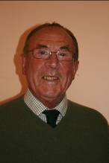

Julian Hooper
Lionsmead House Kingston Road
Tel 01672 870440
julian@lionsmead.net

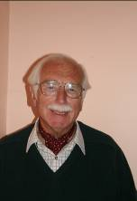
James Moore
Rights of Way Officer, Flooding
The Old Post Office Kingston Road
Tel 01672 870405
jpmoore@onetel.com

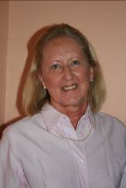

Julia Preston
Environment
Kingston Road


Randle Theobald
Planning, Law & Order, Emergency Planning,
Recreation & Arts, Press
Baverstock Farm Rivar Road
Tel 01672 870505 randliz@tinyworld.co.uk



Stella Zweck
Highways, Flooding
Down Under Rivar Road
Tel 01672 870397
stella.zweck@kennet.gov.uk

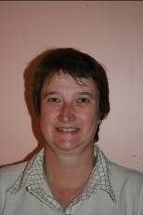

Lois Philipps
Parish Clerk
Meadow Cottage Rivar Road
Tel 01672 871265
l.philipps@btinternet.com

August 2008

